<======================================================================>

**MariaDB**

<======================================================================>

If mariadb:

mariadb -u root

**Checkout service status[mariadb]**

systemctl status mariadb

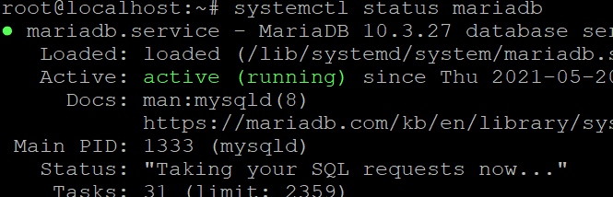

You will be prompted for the password you set for the MySQL root account when you installed the software.

DATABASE + USER + PASSWORD  
NÃO ESQUECER!

SERÁ USADA PARA O PHPMYADMIN E WP-CONF

First, we can create a separate database that WordPress will control

Para facilitar o entendimento vamos uma database chamada: **wordpres**

MariaDB [(none)]> CREATE DATABASE **wordpress** DEFAULT CHARACTER SET utf8 COLLATE utf8_unicode_ci;

We are going to create this account, set a password, and grant access to the database we created. We can do this by typing the following command. Remember to choose a strong password here for your database user:

MariaDB [(none)]> GRANT ALL ON wordpress.* TO **'wordpressuser'**@'localhost' IDENTIFIED BY **'minhasenhaqui'**;

You now have a database and user account, each made specifically for WordPress. We need to flush the privileges so that the current instance of MySQL knows about the recent changes we’ve made:

MariaDB [(none)]> FLUSH PRIVILEGES;

MariaDB [(none)]> EXIT;

Ref more about MariaDB: [Installing phpMyAdmin on Debian 10 – Linux Hint](https://linuxhint.com/install_phpmyadmin_debian_10/)

**Mariadb**

[How to Install LAMP Stack on Ubuntu 20.04 Server/Desktop - LinuxBabe](https://www.linuxbabe.com/ubuntu/install-lamp-stack-ubuntu-20-04-server-desktop)